Route back delivery performance.

Application profile.

Once the first CTP message is received in the Rot, a RBD message is sent every 30 seconds. The destination address is incremented by one every time the RBD message is sent beginning with the Node 2.

Network layout 1.

* RBD Period (30s)
* CTP period (1s)
* Duty Cycle 100%
* RX/TX Success 100%
* RBD Table size ROOT and CLIENT. 20 elements

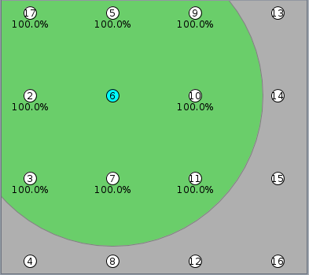

**Router**

Results:

Delivery time (ms)

* Mean 32
* Maximum 128

RBD Traffic

**Router**

* Maximum hop distance = 4. From Router to Node16 (0🡪6🡪10🡪15🡪16)
* RBD Msgs: Msg RBD received as final destination
* FWD Msgs: RBD messages forwarded to other nodes.
* Total: Sum of RBD and FWD Msgs.
* RBD Table Full 0 Times
* RBD Error Reports send 0
* Route recovery time –
* Duplicated RBD messages received by the application layer. Total. 1 (node 15)